Accessing the Metadata
We access the BCI Competition IV 2a dataset through the MOABB python framework. All the information about the dataset can be accessed through moabb.datasets.BNCI2014_001.METADATA and the figure below summarizes how the total sample (i.e. trials) count is made of. In addition to that the following details in the table are available as metadata
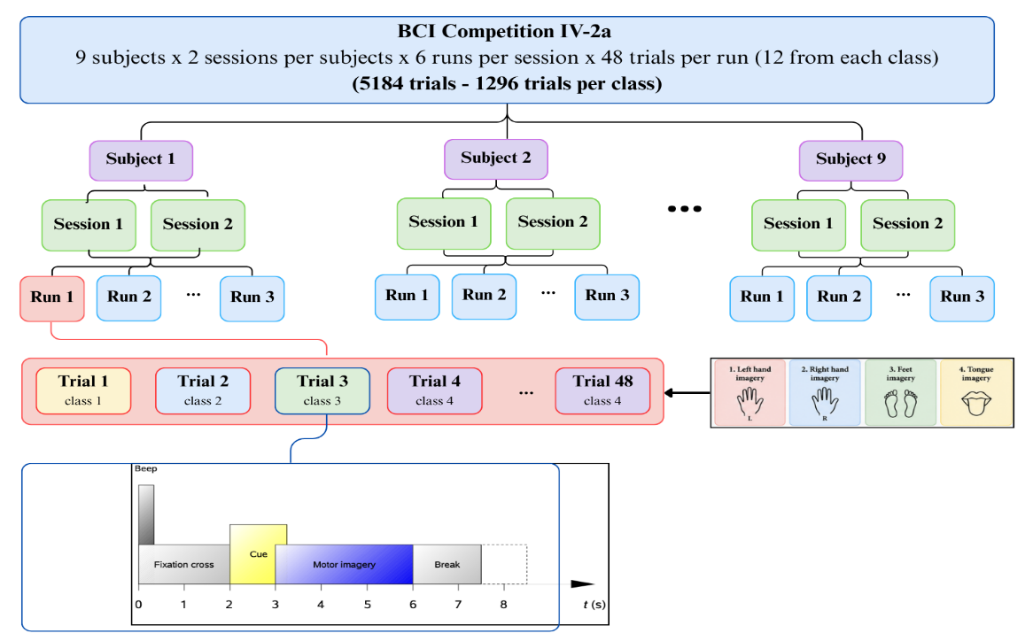
Sampling frequency | 250 Hz
No of Channels | 22 EEG Channels + 3 OEG Channels
Filters at Acquisition | 0.5-100Hz Bandpass Filter and a notch filter at 50 Hz
Duration of the Motor Imagery task | 4S (2S -6S)

Accessing the EEG Data
The dataset was accessed using the MOABB framework motor imagery paradigm, which defines the default analysis interval as [2, 6] seconds (i.e. interval that the subject performs a motor imagery task but e can change the interval as we want). 5,184 EEG epochs were extracted across nine subjects and two recording sessions (1296 trials per each class). Each extracted epoch contains 22 EEG channels (EOG channels are discarded in default) and 1,001-time samples at a sampling frequency of 250 Hz.
However, the original continuous recordings remain accessible through MOABB, allowing alternative analysis windows to be selected if required.
Analysing Data
First, we analyse the Power Spectral Density of each channel averaging over all the channels to check whether we can identify significant brain activities in the EEG data. According to the literature, the mu (8–13 Hz) and beta (13–30 Hz) frequency bands have a strong association with sensorimotor activity during motor imagery [1] [2].

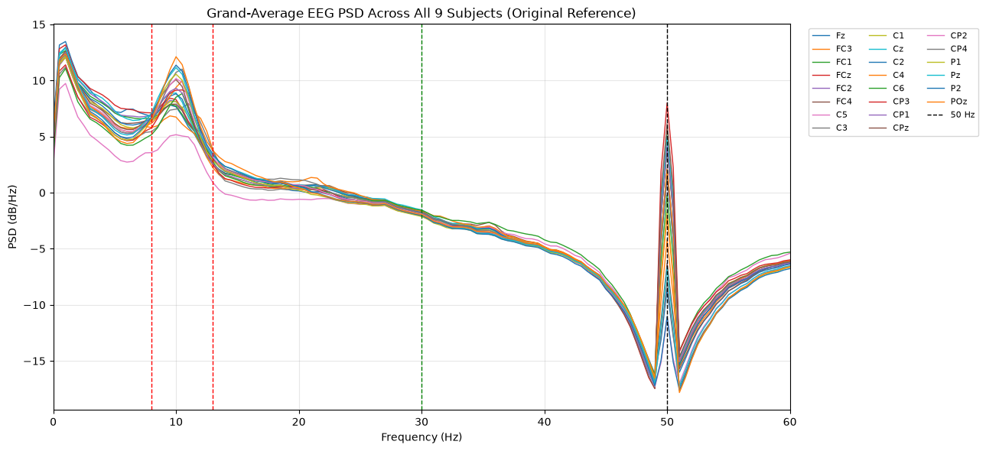
During the analysis of our dataset a prominent spectral peak near 10 Hz was observed in most EEG channels, consistent with alpha activities and potentially sensorimotor mu rhythms (8–13 Hz). Although no similarly prominent beta-band peak (13–30 Hz) was observed, smaller peaks were visible around 20 Hz.
Further, higher power at low frequencies may partly reflect EOG artifacts. Additionally, a pronounced peak near 50 Hz remained despite the reported notch filtering, suggesting possible residual interference that requires further investigation. So, we apply a band pass filter between 4 – 40 Hz which contain the necessary information for our analysis.
Further, we analyzed the scalp topographies, differences in spectral power to identify any differences between classes.
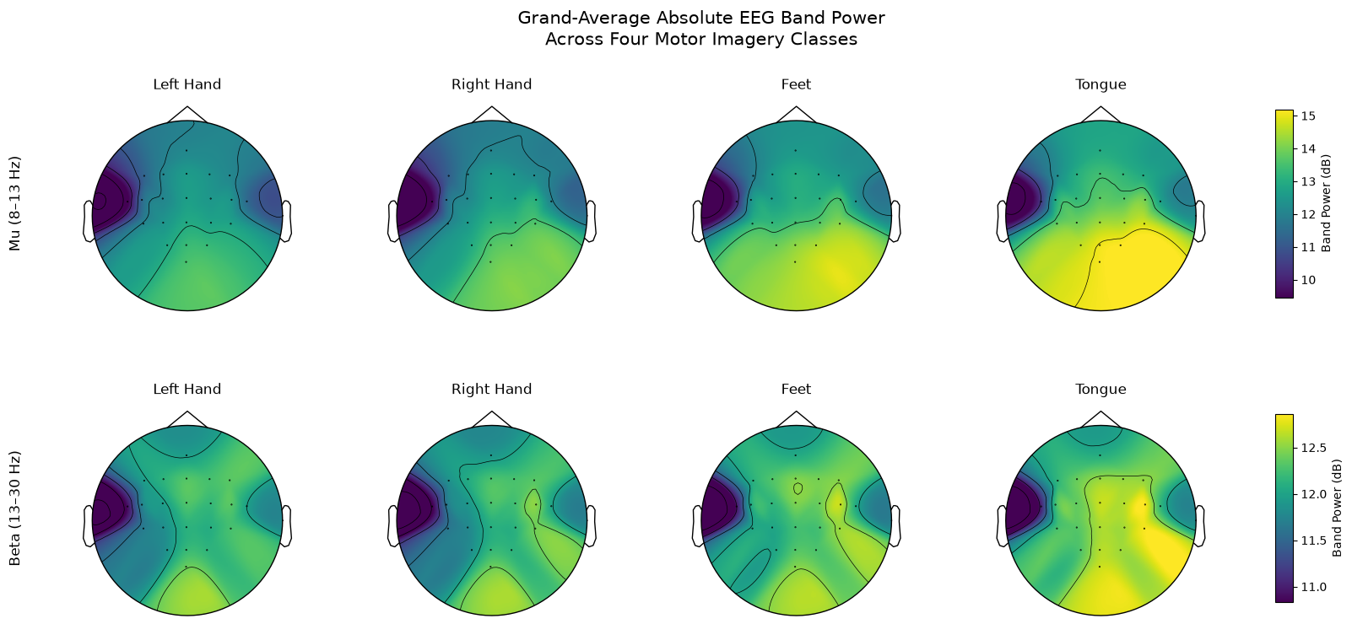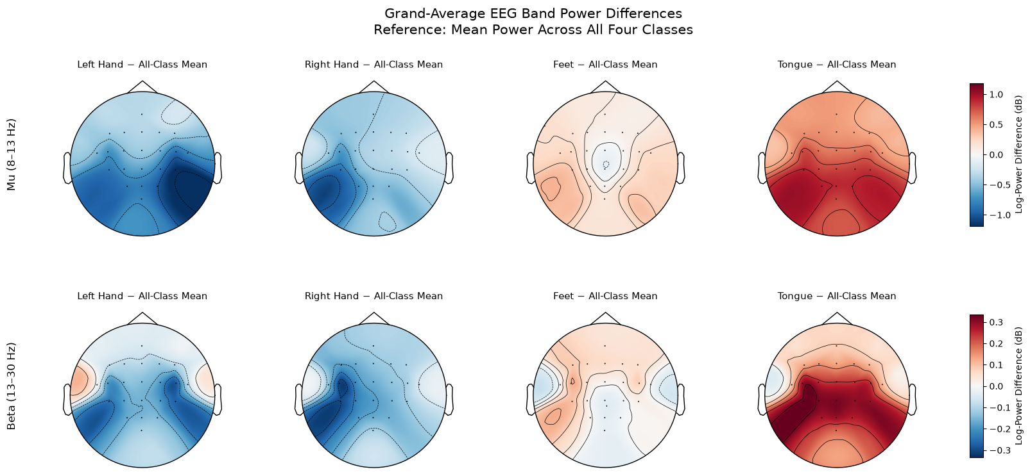
However, in these topographies we can’t observe any prominent physiologically meaningful differences between four classes. However, still there can be slight differences. Therefore, to identify those changes we subtracted each power spectral density of each class from the grand average across all classes and obtained the log value.
Here, we can observe clear, physiologically meaningful differences between classes, which align with the literature [2][3]. Notably, there is a strong difference between left- and right-hand motor imagery, which is desirable, as the within-session mean classification accuracy for these two classes is approximately 81.10% [4]. However, when considering all four classes, the within-session mean accuracy drops to 61.34% [4], indicating that current algorithms face greater challenges. This is also understandable from the plots, where differences between feet and tongue imagery are less apparent. This motivates investigating RSNNs, which are biologically inspired and may identify subtle temporal patterns that conventional methods might overlook.

[1] Yu H, Ba S, Guo Y, Guo L, Xu G. Effects of Motor Imagery Tasks on Brain Functional Networks Based on EEG Mu/Beta Rhythm. Brain Sci. 2022 Jan 30;12(2):194. doi: 10.3390/brainsci12020194. PMID: 35203957; PMCID: PMC8870302.
[2] McFarland, D.J., Miner, L.A., Vaughan, T.M. et al. Mu and Beta Rhythm Topographies During Motor Imagery and Actual Movements. Brain Topogr 12, 177–186 (2000). https://doi.org/10.1023/A:1023437823106
[3] C. L. Maeder, C. Sannelli, S. Haufe and B. Blankertz, "Pre-Stimulus Sensorimotor Rhythms Influence Brain–Computer Interface Classification Performance," in IEEE Transactions on Neural Systems and Rehabilitation Engineering, vol. 20, no. 5, pp. 653-662, Sept. 2012, doi: 10.1109/TNSRE.2012.2205707.
[4]“moabb.datasets.BNCI2014_001,” MOABB Documentation. [Online]. Available: https://moabb.neurotechx.com/docs/generated/moabb.datasets.BNCI2014_001.html. [Accessed: Oct. 15, 2026].

